**Wire-Frame Design**

**BIG MART SALES PREDICTION**

|  |  |
| --- | --- |
| Written By | Gaurav.G.Singh |
| Document Version | 1.0 |
| Last Revised Date | 28-03-2024 |

**Document Change Control Record**

|  |  |  |  |
| --- | --- | --- | --- |
| **Version** | **Date** | **Author** | **Comments** |
|  |  |  |  |
|  |  |  |  |
|  |  |  |  |
|  |  |  |  |
|  |  |  |  |
|  |  |  |  |
|  |  |  |  |
|  |  |  |  |
|  |  |  |  |
|  |  |  |  |
|  |  |  |  |
|  |  |  |  |
|  |  |  |  |
|  |  |  |  |
|  |  |  |  |
|  |  |  |  |

**Reviews**

|  |  |  |  |
| --- | --- | --- | --- |
| **Version** | **Date** | **Reviewer** | **Comments** |
|  |  |  |  |

### **Approval Status:**

|  |  |  |  |  |
| --- | --- | --- | --- | --- |
| **Version** | **Review date** | **Reviewed By** | **Approved By** | **Comments** |
|  |  |  |  |  |

**Raw Test Data**

This is the Row test date the code is on Github

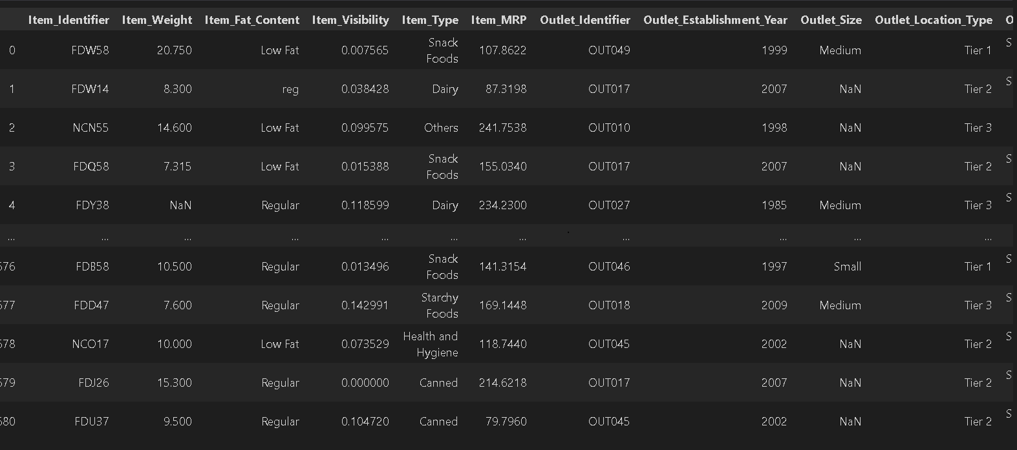

**Prediction Values**

This the Perdicted Values:

